**USER INTERFACE DESIGN**

**<CREATE ACCOUNT>**

1. **UI DESCRIPTION AND RELATED REQUIREMENTS**

The CREATE ACCOUNT user interface design purpose is to handle the process for the user creating a new account.

This UI satisfies the following Requirements:

* REQ # 2.0

1. **UI SCREENSHOT**

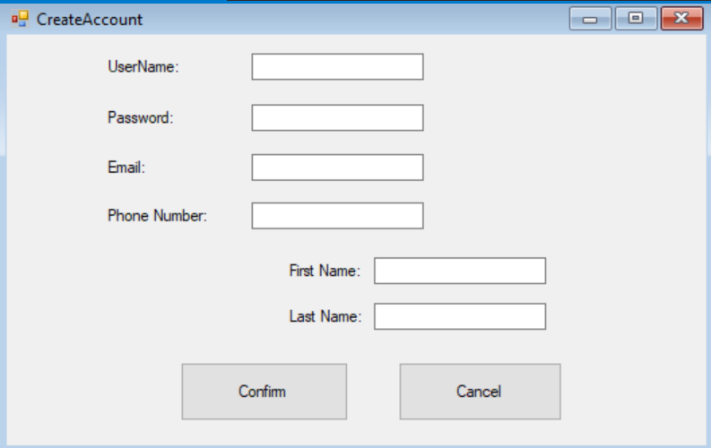

1. **UI DETAILED DESCRIPTION**

|  |  |  |
| --- | --- | --- |
| Field Name | Type | Purpose and/or Action(s) to Perform |
| userName | textbox | Holds the username.Max size = 20. Min size = 8. |
| userPWD | textbox | Holds the password. Min size = 8. |
| firstName | textbox | Holds the first name. Max size = 15. |
| lastName | textbox | Holds the last name. Max size = 15. |
| emailAddress | textbox | Holds the email address. Max size = 50. |
| phoneNumber | textbox | Holds the phone number. Min size = 7. Max size = 10. |
| submit | button | Stores information in all text fields to new users’ accounts in the account database. |
| cancel | button | closes the form. |
|  |  |  |
|  |  |  |
|  |  |  |
|  |  |  |
|  |  |  |
|  |  |  |